VOICE GUIDANCE AND ULTRASONIC SENSOR BASED OBSTACLE AVOIDANCE FOR BLIND

The main aim of the project is to design a voice based alerting system for the blind based on ultrasonic sensor for obstacle detection and voice circuit for voice based announcements. This advantage of this device is voice based announcement for easy navigation i.e. the user gets the voice which pronounces the directions he need to move to reach his destination.

Ultrasonic Sensor senses the obstacles in its path by continuously transmitting the ultrasonic waves. If any obstacle comes in its vicinity then the ultrasonic waves get reflected back to the system. The ultrasonic receiver senses these ultrasonic waves and this information are passed to the Microcontroller. The microcontroller gives alerts through voice message.

The controlling device of the whole system is a Microcontroller. The user gets alerts through voices using voice circuit system which is interfaced to Microcontroller. This system is equipped with three ultrasonic sensors, which are capable of detecting obstacles in its path and controller alerts the user through voice circuit in case of any obstacles in that particular direction, which helps the user to avoid obstacles in its way. This system is very helpful or blind people. The Microcontroller is programmed using Embedded C language.

The main features of this project are:
- Voice based alerts.
- Obstacle detection.

This project provides learning’s on the following advancements:
- Interfacing ultrasonic sensor modules to Microcontroller.
- Voice circuit.
- Interfacing voice circuit to Microcontroller.
- Embedded C programming.
- PCB designing.

The major building blocks of this project are:

- Regulated Power Supply
- Microcontroller.
- Crystal Oscillator
- Reset button
- Voice circuit.
- LED indicators.
- Ultrasonic sensors.
- Buzzer.

Software’s used:

- PIC-C compiler for Embedded C programming.
- PIC kit 2 programmer for dumping code into Micro controller.
- Express SCH for Circuit design.
- Proteus for hardware simulation.

Regulated Power Supply:

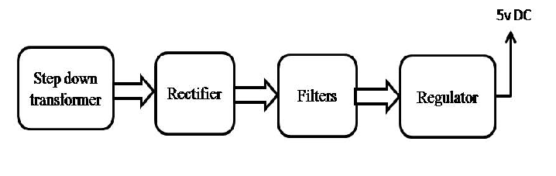

Block diagram:

